IT24104030 Withanage T.R.

**Probability and Statistics – IT2120**

# Lab 5 Exercise 2 1)

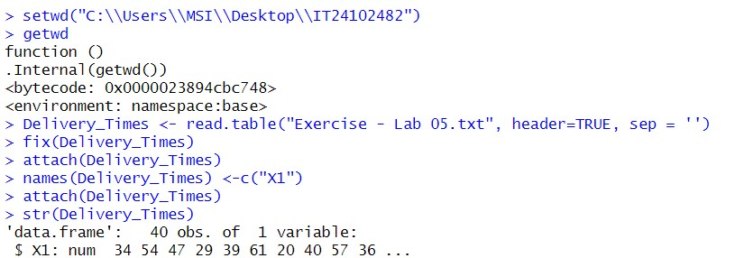

# 2)

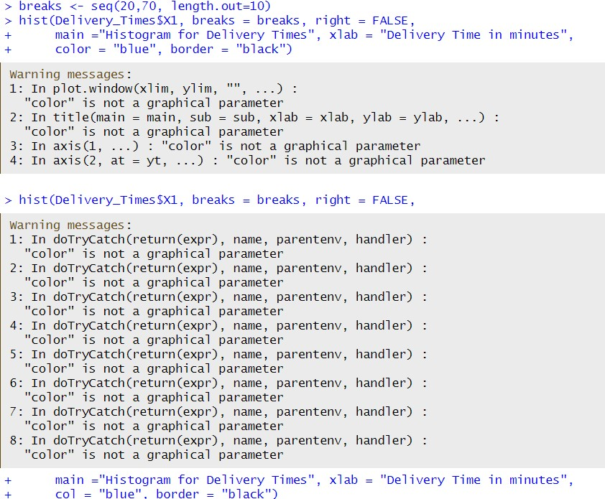

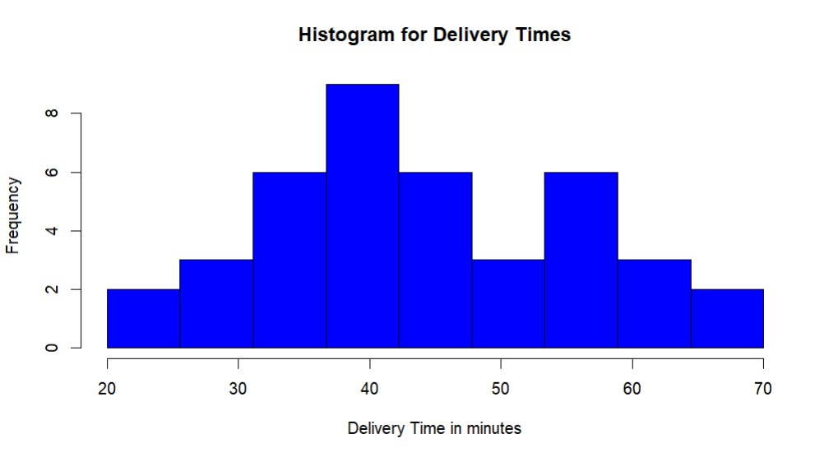

# Positively skewed 4)

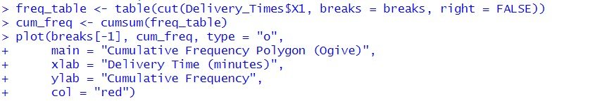

# 5)

